**Cpt 38**

**Homework (Simulation)**

1. **Use the simulator to perform some basic RAID mapping tests. Run with different levels (0, 1, 4, 5) and see if you can figure out the mappings of a set of requests. For RAID-5, see if you can figure out the difference between left-symmetric and left-asymmetric layouts. Use some different random seeds to generate different problems than above.**

python3 raid.py -L 0 -s 0 -n 5 -c

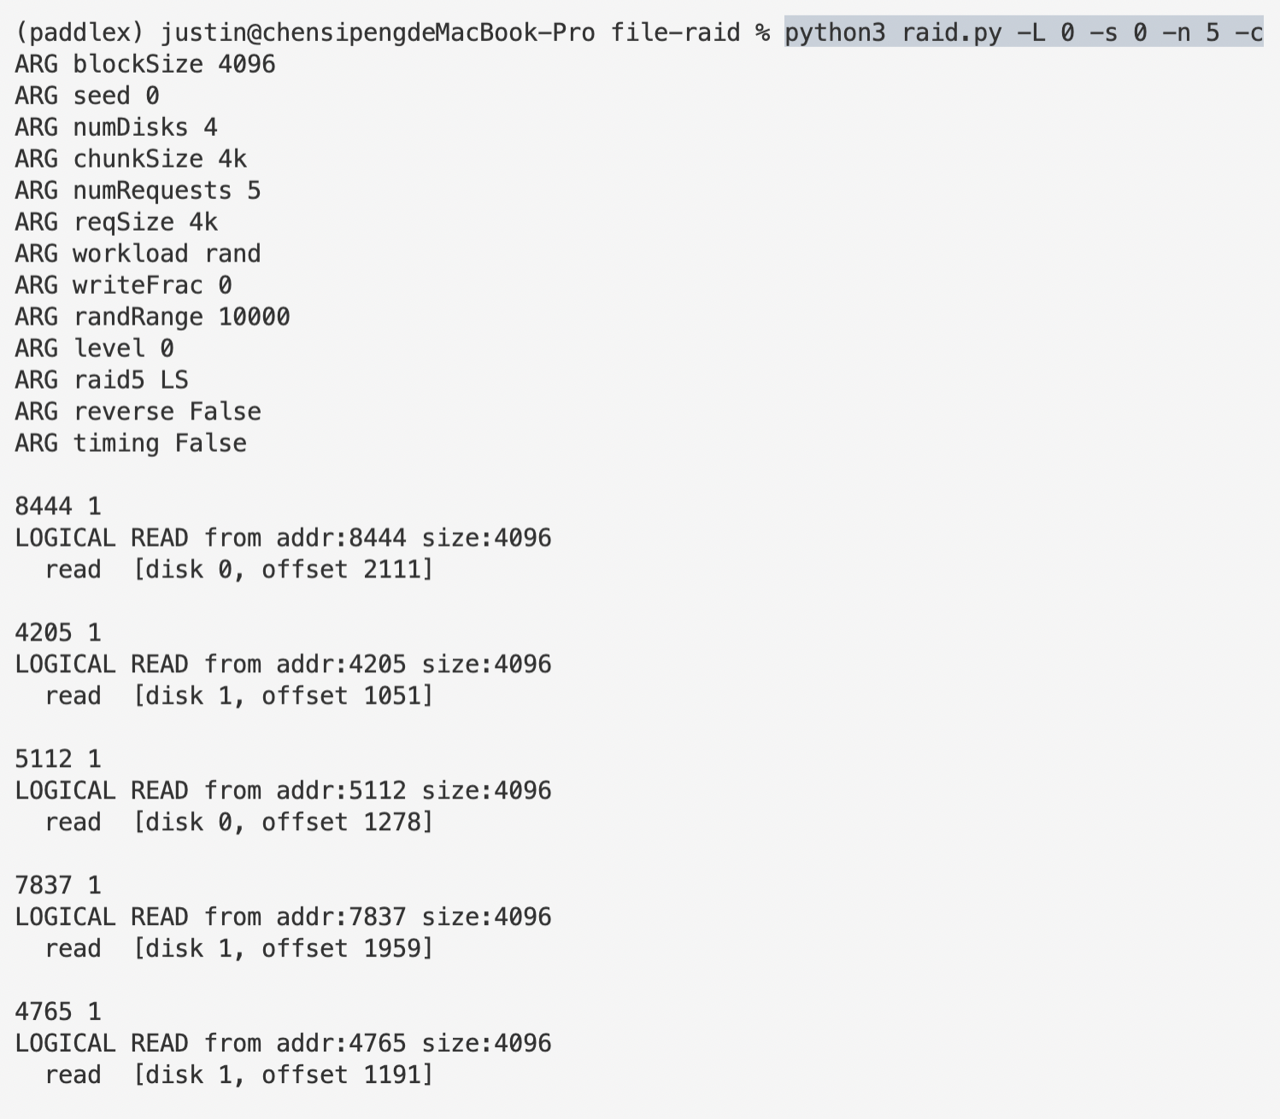

For RAID-0, since we don’t have any redundant disks, the disk number is simply the remainder of the address when divided by chunk size, and offset is the quotient.

python3 raid.py -L 1 -s 0 -n 5 -c

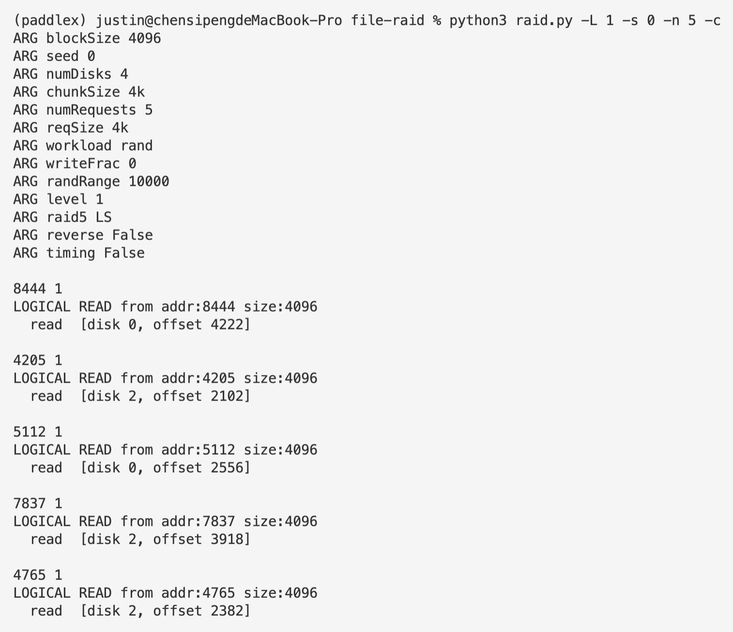

For RAID-1, the disk number is twice that of RAID-0, simply because for RAID-1 we have a exact same copy of each disk. Correspondingly, offset is twice that of RAID-0, which is also the quotient of address divided by half of the chunk size.

python3 raid.py -L 4 -s 0 -n 5 -c

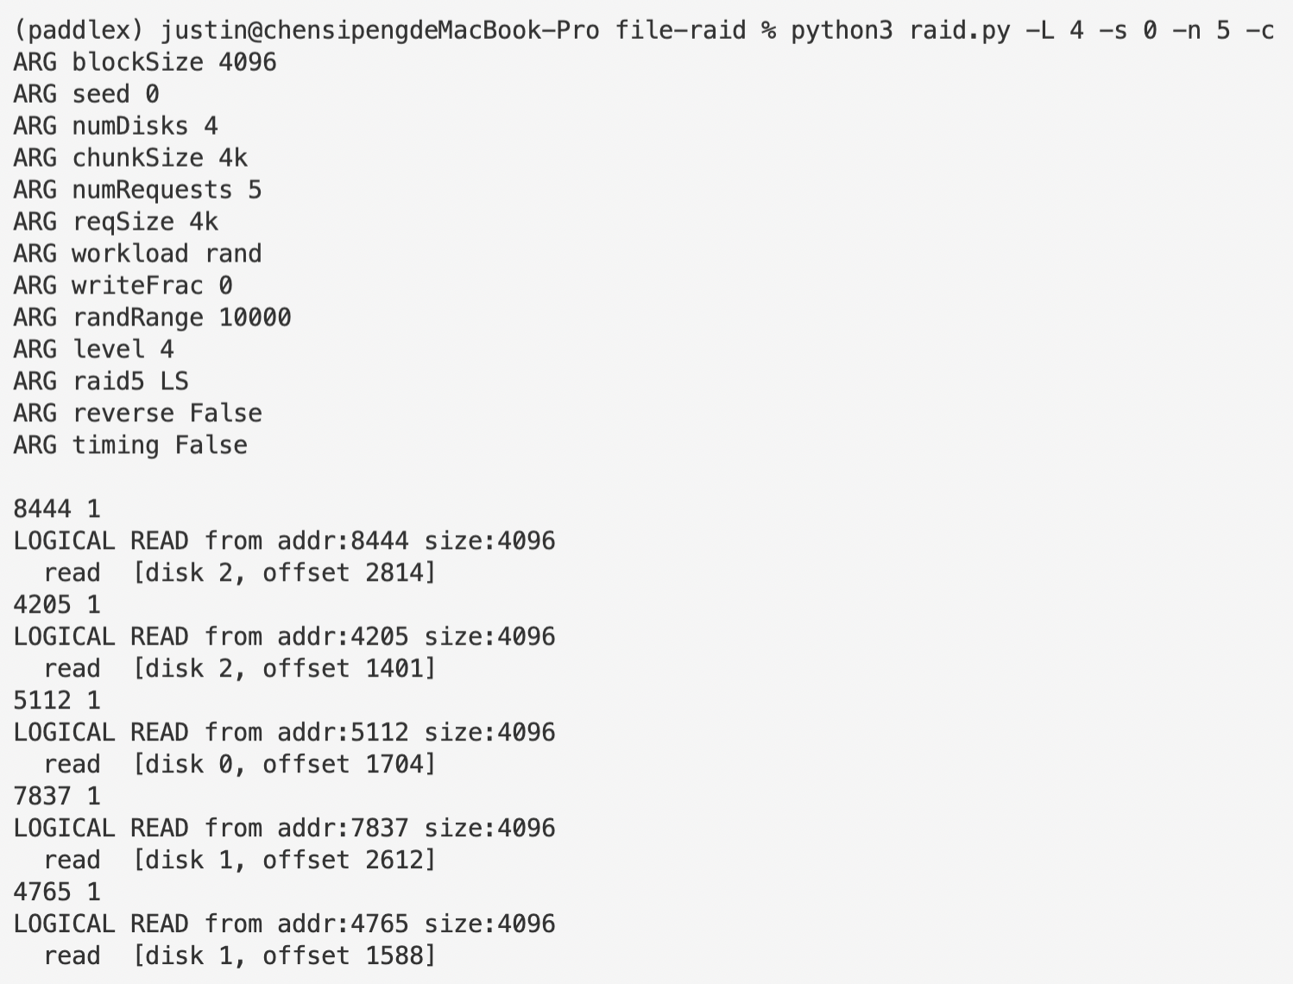

For RAID-4, each stripe spares one disk to store parity value, while the rest three disks still contain genuine data. In the case above, the number of disks that store real data is 3 since we have altogether 4 disks. Thus, disks number is the remainder of address divided by 3 and offset is the quotient.

python3 raid.py -L 5 -s 0 -n 5 -c -5 LS

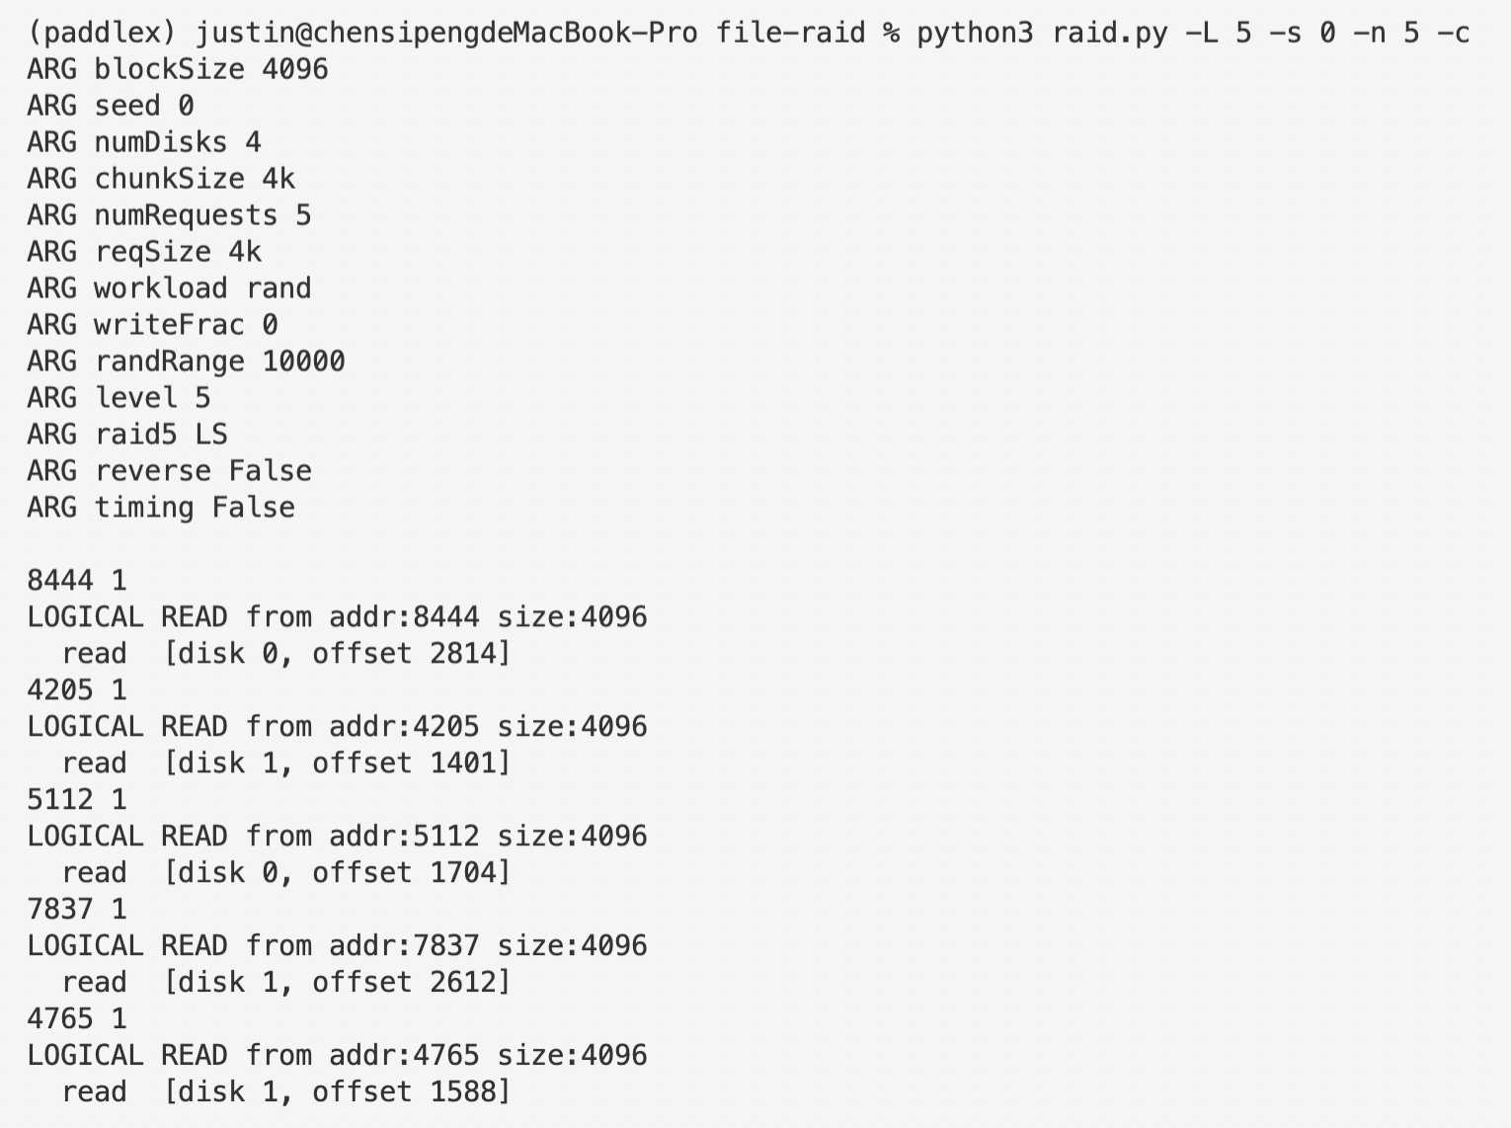

python3 raid.py -L 5 -s 0 -n 5 -c -5 LA

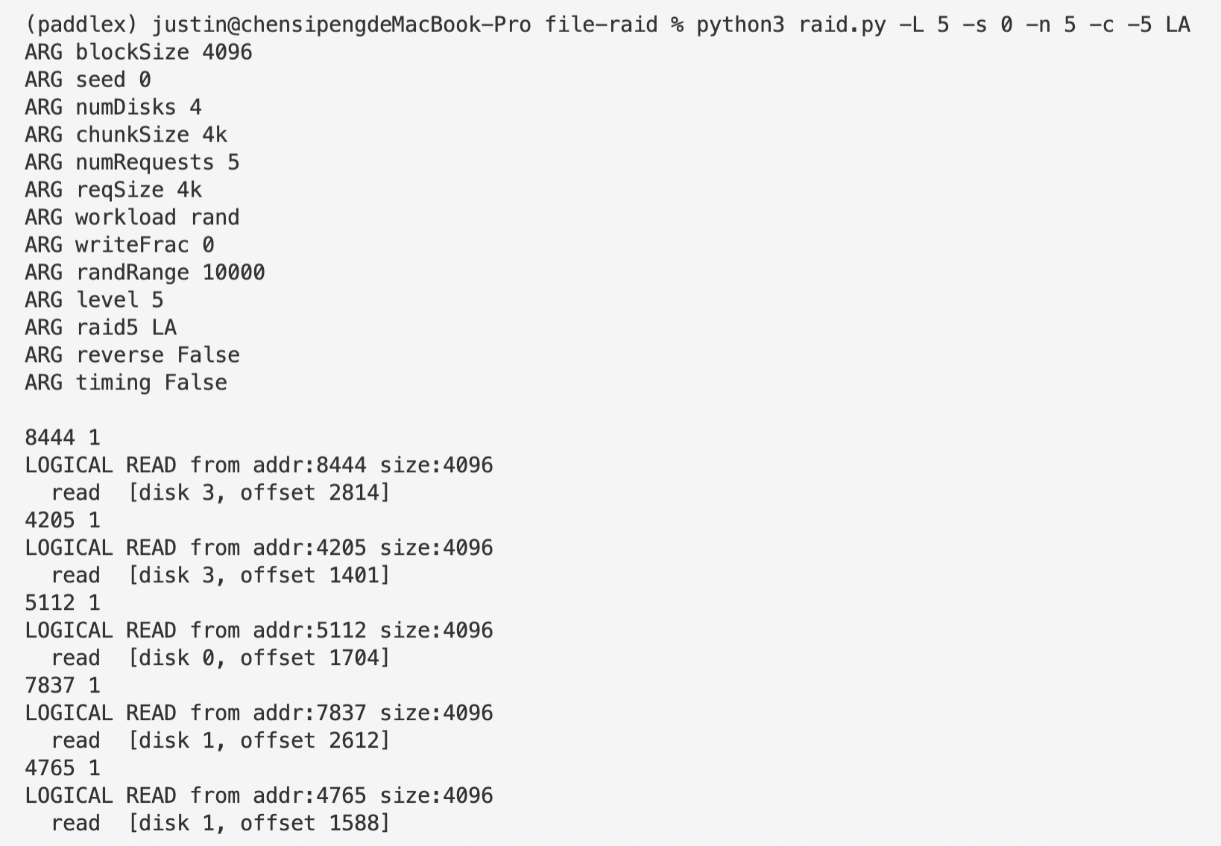

For RAID-5, like RAID-4, each stripe has a spare disk for parity. What is different is that RAID-5 distributes the parity chunks in all four disks. Thus, offset is completely identical for RAID-5 and RAID-4, but disk number for RAID-5 is calculated by ( ( ( - offset % 4 + 5) % 5 ) + addr % 4 ) % 4 for left-symmetrical cases and ( ( ( - offset % 4 + 5) % 5 ) > addr % 4 ) * 1 + addr % 4 for left-asymmetrical cases.

1. **Do the same as the first problem, but this time vary the chunk size with -C. How does chunk size change the mappings?**

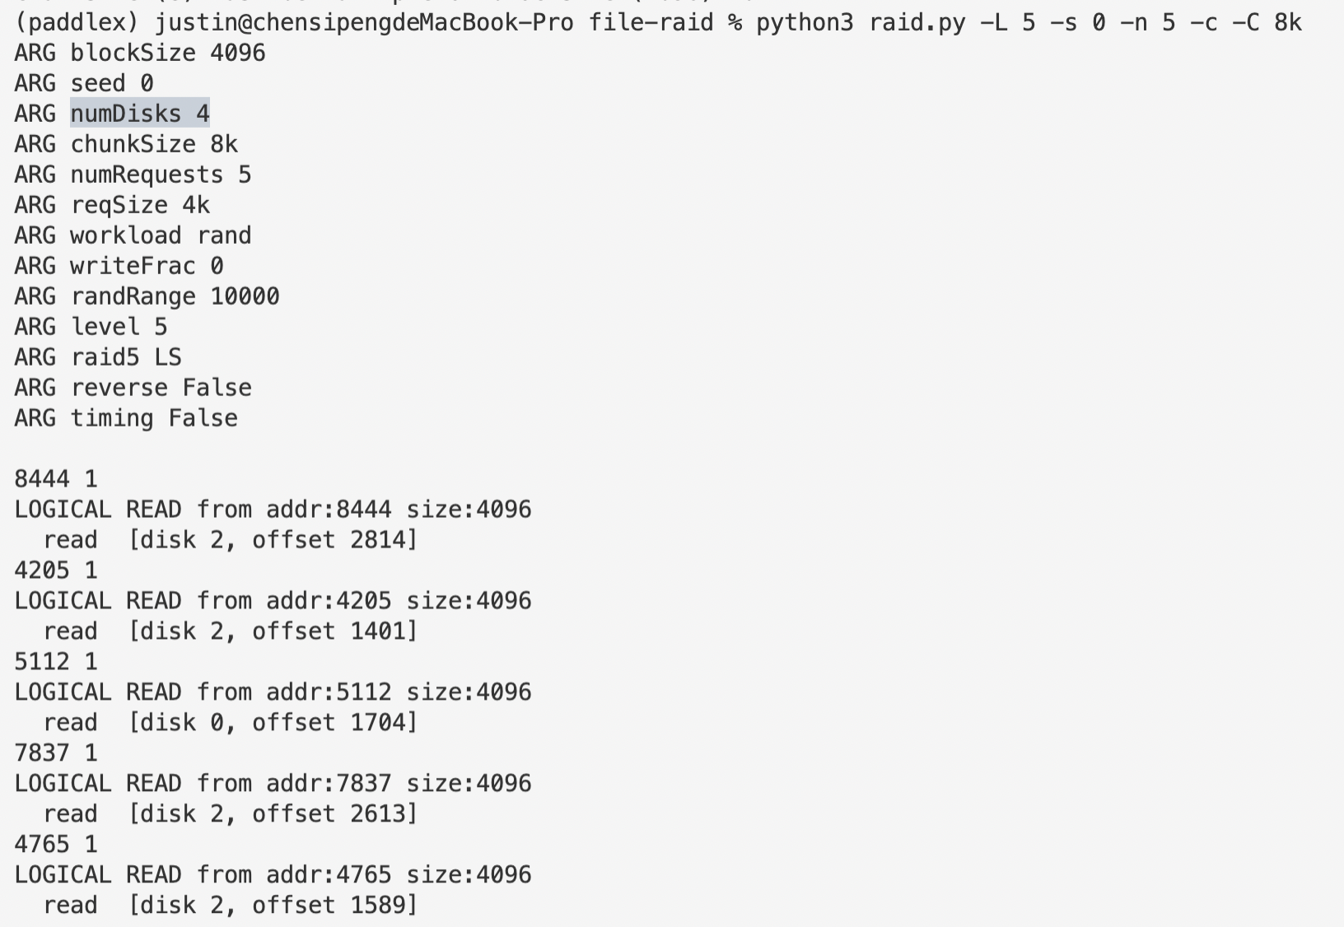

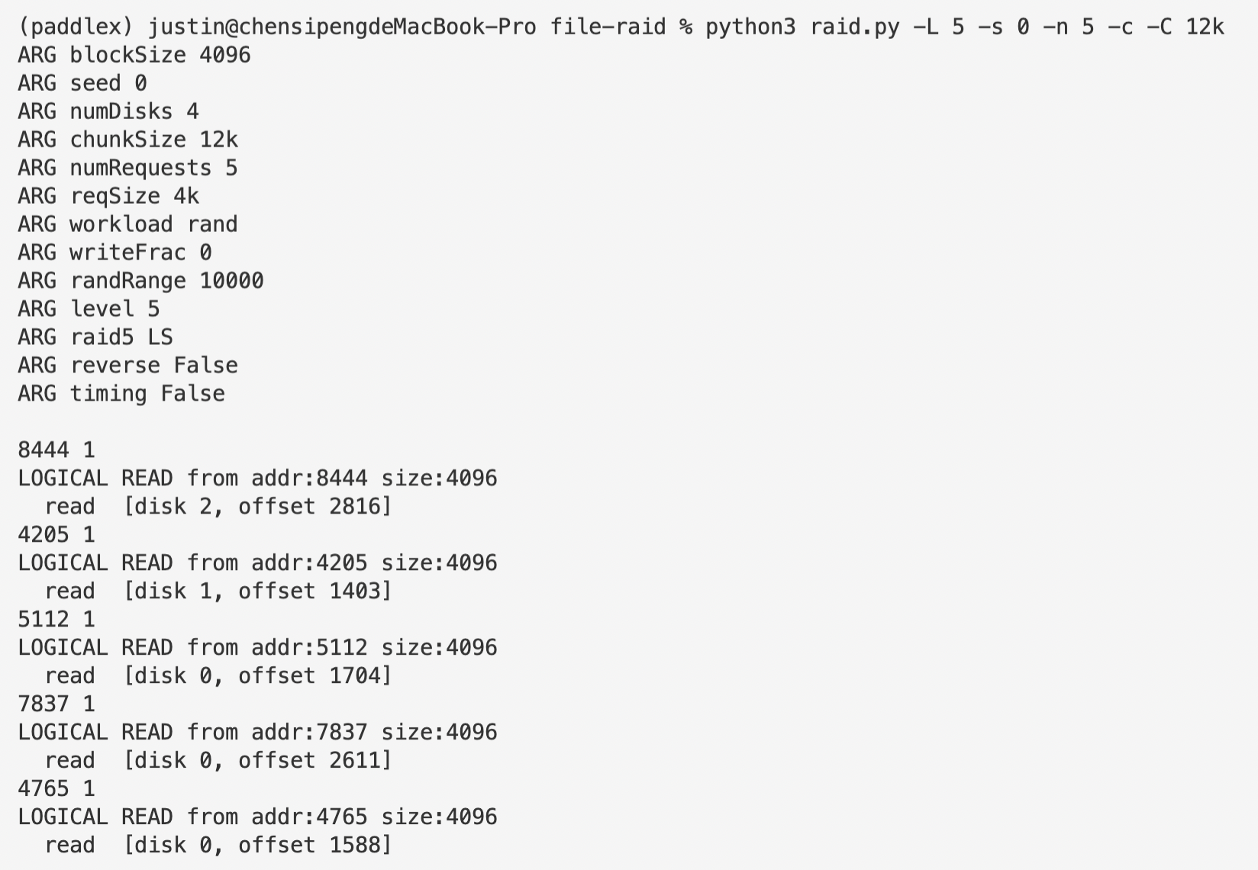

Different chunk sizes determines how many chunks of data to be place continuously on one single disk.

1. **Do the same as above, but use the -r flag to reverse the nature of each problem.**

python3 raid.py -L 5 -s 0 -n 5 -c -r

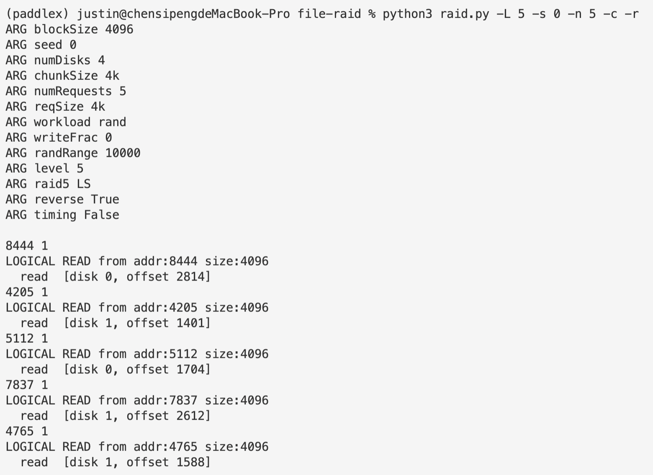

1. **Now use the reverse flag but increase the size of each request with the -S flag. Try specifying sizes of 8k, 12k, and 16k, while varying the RAID level. What happens to the underlying I/O pattern when the size of the request increases? Make sure to try this with the sequential workload too (-W sequential); for what request sizes are RAID-4 and RAID-5 much more I/O efficient?**

python3 raid.py -r -n 50 -L 0 -S 8k -W seq -t -c

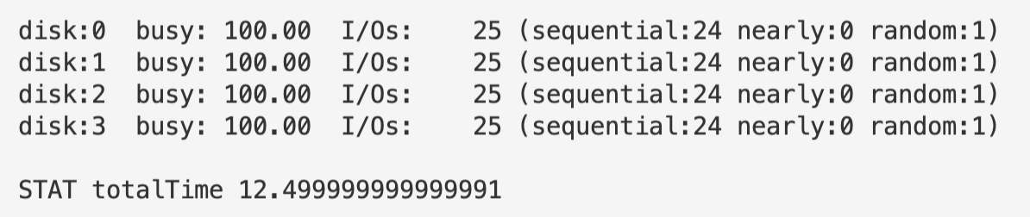

python3 raid.py -r -n 50 -L 0 -S 12k -W seq -t -c

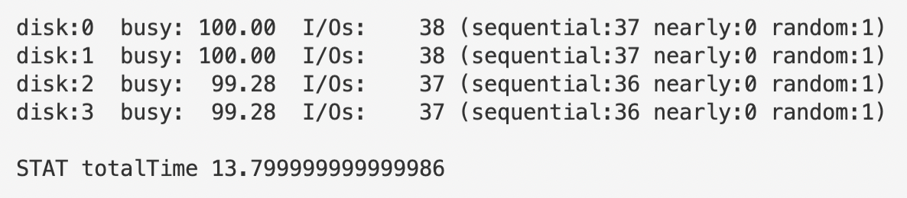

python3 raid.py -r -n 50 -L 0 -S 16k -W seq -t -c

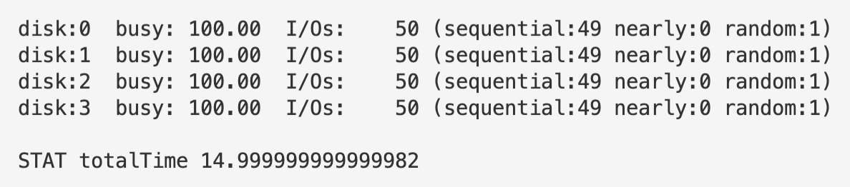

python3 raid.py -r -n 50 -L 1 -S 8k -W seq -t -c

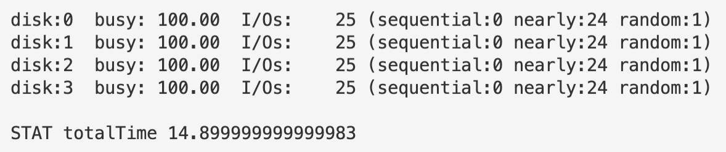

python3 raid.py -r -n 50 -L 1 -S 12k -W seq -t -c

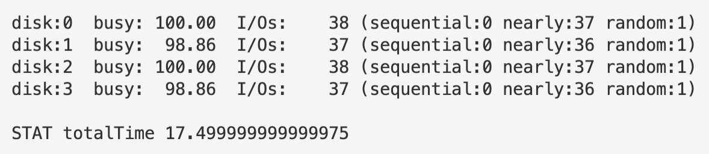

python3 raid.py -r -n 50 -L 1 -S 16k -W seq -t -c

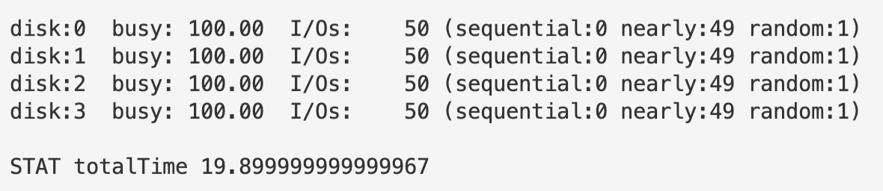

python3 raid.py -r -n 50 -L 4 -S 8k -W seq -t -c

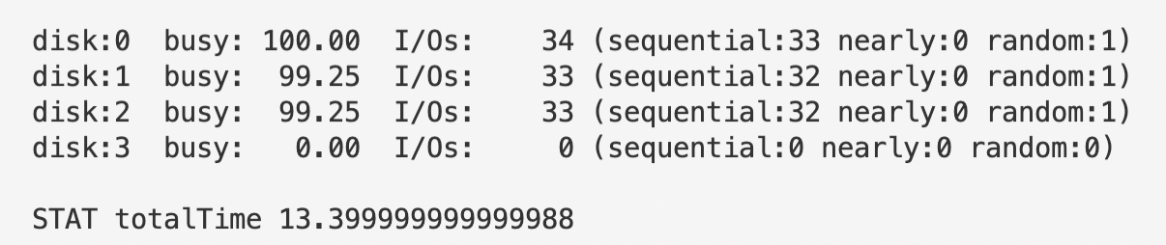

python3 raid.py -r -n 50 -L 4 -S 12k -W seq -t -c

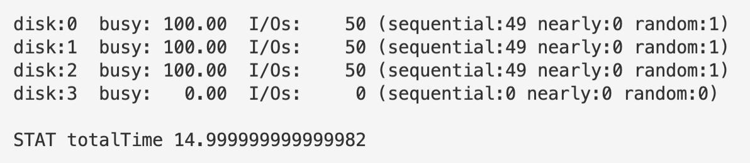

python3 raid.py -r -n 50 -L 4 -S 16k -W seq -t -c

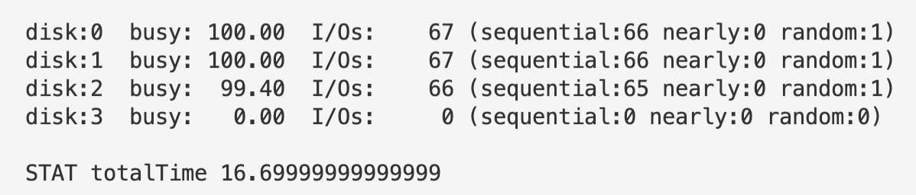

python3 raid.py -r -n 50 -L 5 -S 8k -W seq -t -c

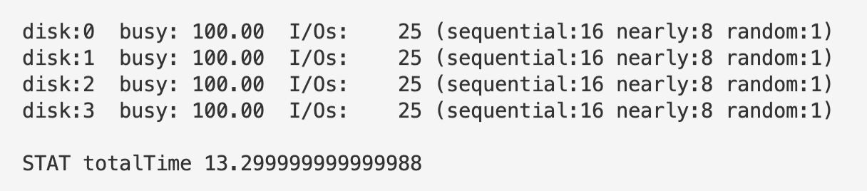

python3 raid.py -r -n 50 -L 5 -S 12k -W seq -t -c

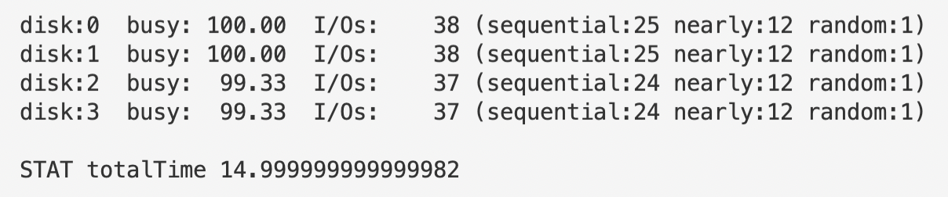

python3 raid.py -r -n 50 -L 5 -S 16k -W seq -t -c

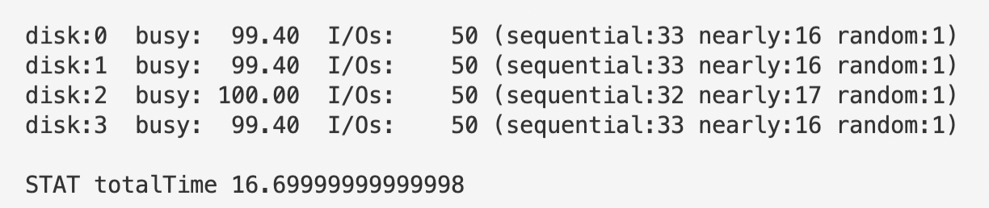

For RAID-4, IO efficiency is highest when size of request is 12k, which means that one single request needs to access 3 chunks at a time. This should be attributed to the fact that RAID-4 allows to only read 3 disks at a time since we have a spare disk storing parity. For RAID-5, however, efficiency peaks when size of request is 8k.

1. **Use the timing mode of the simulator (-t) to estimate the performance of 100 random reads to the RAID, while varying the RAID levels, using 4 disks.**

python3 raid.py -L 0 -n 100 -t -c

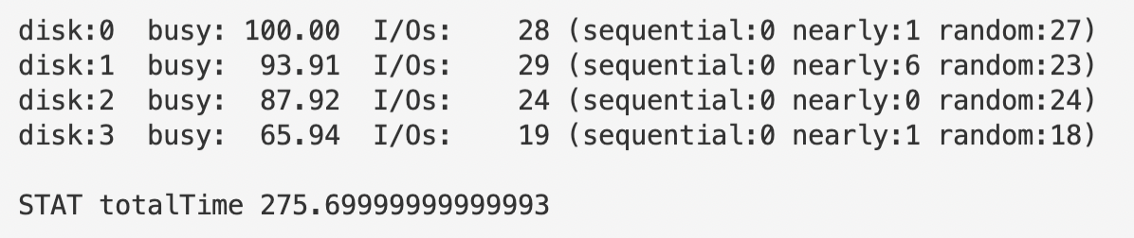

python3 raid.py -L 1 -n 100 -t -c

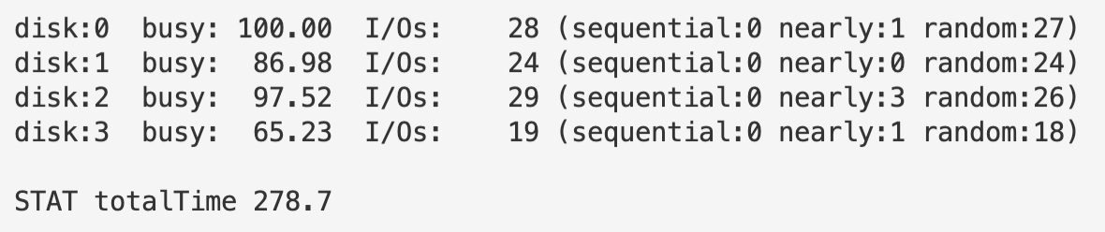

python3 raid.py -L 4 -n 100 -t -c

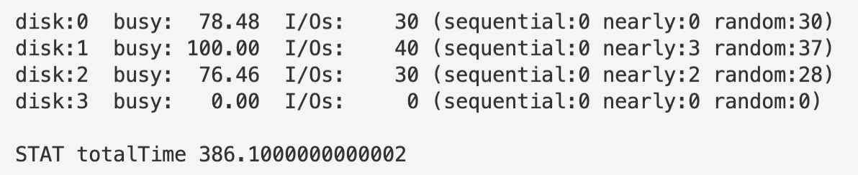

python3 raid.py -L 5 -n 100 -t -c

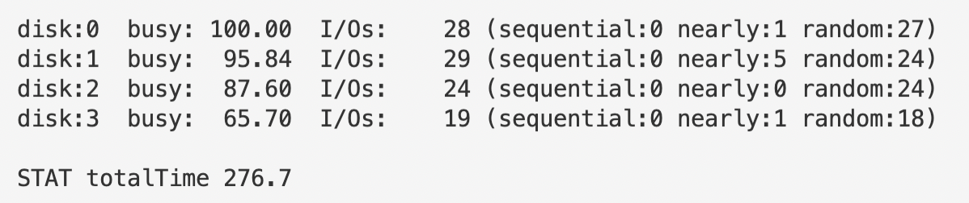

1. **Do the same as above, but increase the number of disks. How does the performance of each RAID level scale as the number of disks increases?**

python3 raid.py -L 0 -n 100 -t -c -D 8

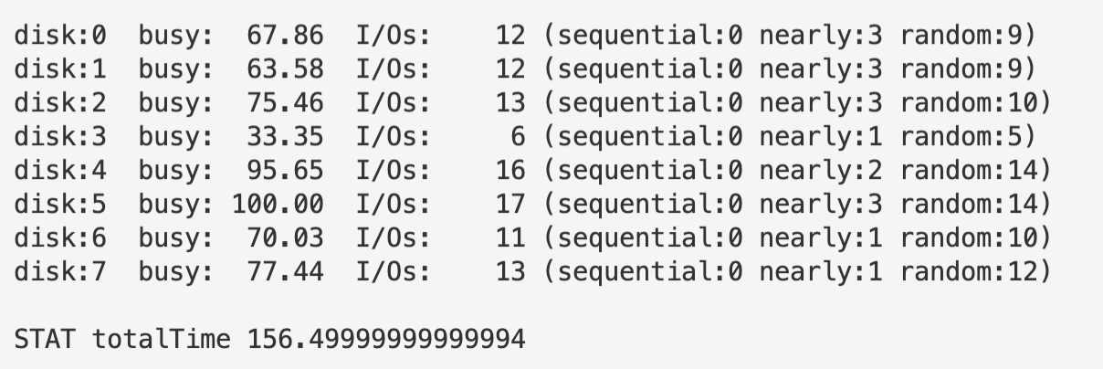

python3 raid.py -L 1 -n 100 -t -c -D 8

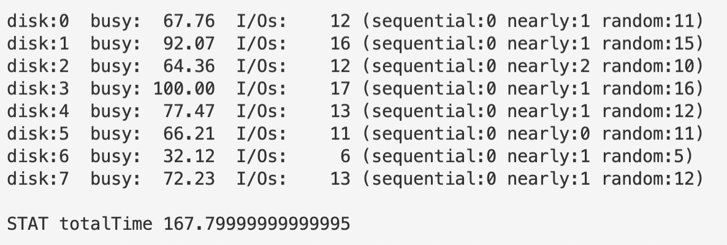

python3 raid.py -L 4 -n 100 -t -c -D 8

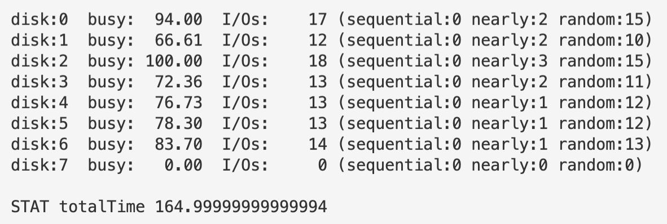

python3 raid.py -L 5 -n 100 -t -c -D 8

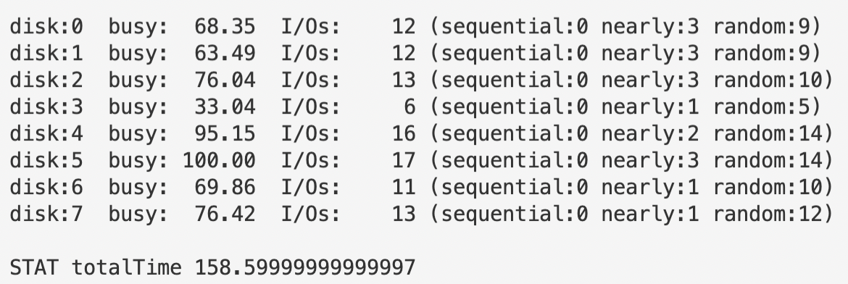

Total time cost is reduced regardless of the RAID level.

1. **Do the same as above, but use all writes (-w 100) instead of reads. How does the performance of each RAID level scale now? Can you do a rough estimate of the time it will take to complete the workload of 100 random writes?**

python3 raid.py -L 0 -n 100 -t -c -w 100

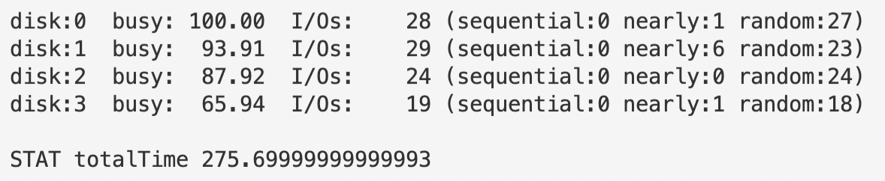

python3 raid.py -L 1 -n 100 -t -c -w 100

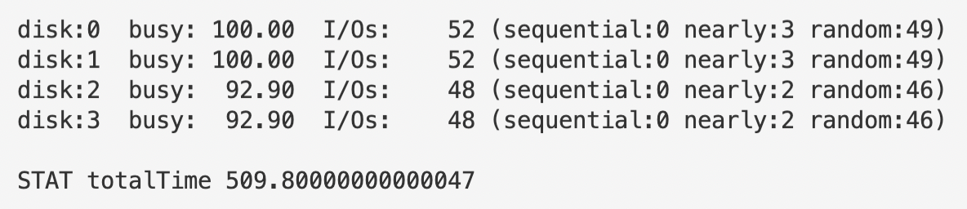

python3 raid.py -L 4 -n 100 -t -c -w 100

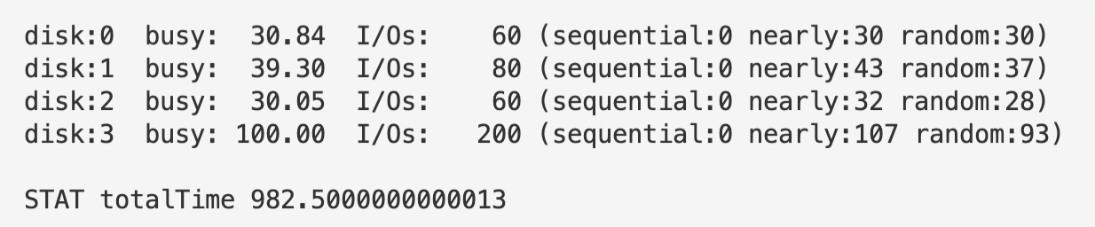

python3 raid.py -L 5 -n 100 -t -c -w 100

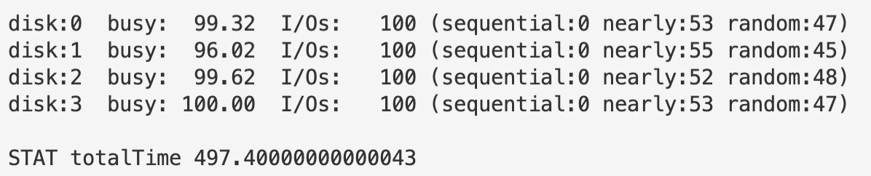

Calculate the total time cost for sequential writes, then compute the answer using the ratio deducted by the formula on the textbook.

1. **Run the timing mode one last time, but this time with a sequential workload (-W sequential). How does the performance vary with RAID level, and when doing reads versus writes? How about when varying the size of each request? What size should you write to a RAID when using RAID-4 or RAID-5?**

python3 raid.py -L 0 -n 100 -w 100 -W seq -t -c

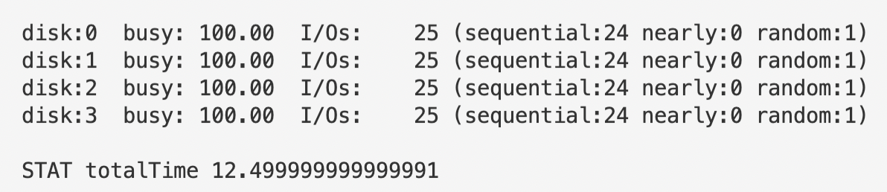

python3 raid.py -L 1 -n 100 -w 100 -W seq -t -c

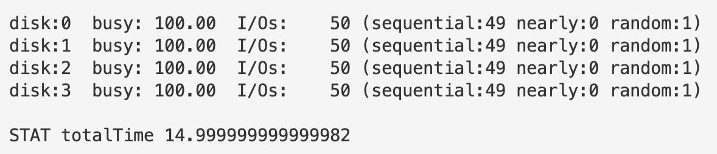

python3 raid.py -L 4 -n 100 -w 100 -W seq -t -c

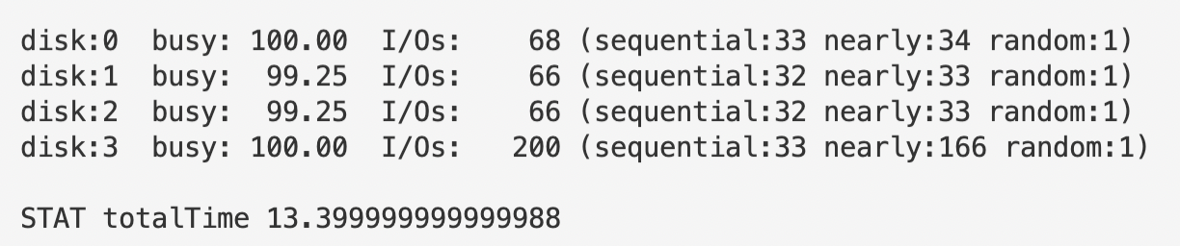

python3 raid.py -L 5 -n 100 -w 100 -W seq -t -c

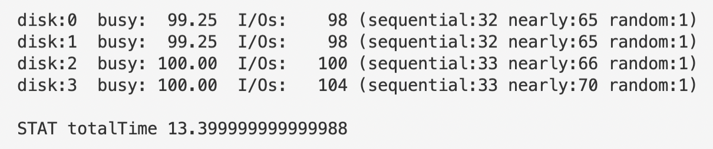

Now try to alter the request size for RAID-4 and RAID-5:

python3 raid.py -L 4 -n 100 -w 100 -W seq -t -c -S 8k

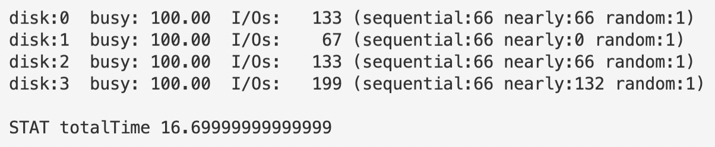

python3 raid.py -L 4 -n 100 -w 100 -W seq -t -c -S 12k

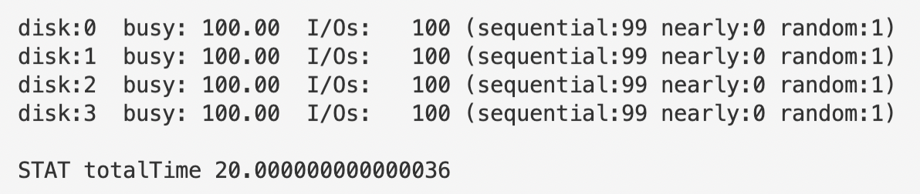

python3 raid.py -L 4 -n 100 -w 100 -W seq -t -c -S 16k

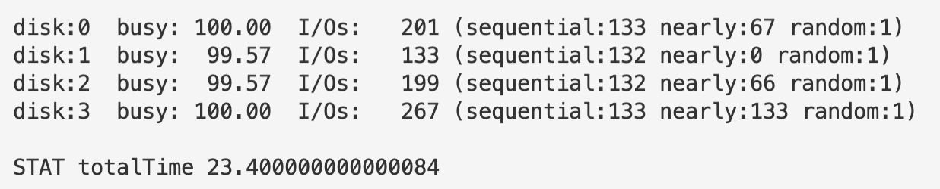

python3 raid.py -L 5 -n 100 -w 100 -W seq -t -c -S 8k

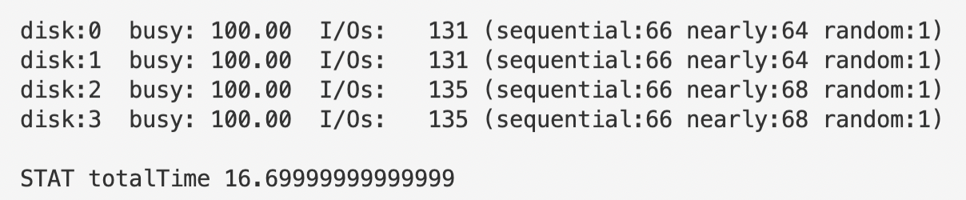

python3 raid.py -L 5 -n 100 -w 100 -W seq -t -c -S 12k

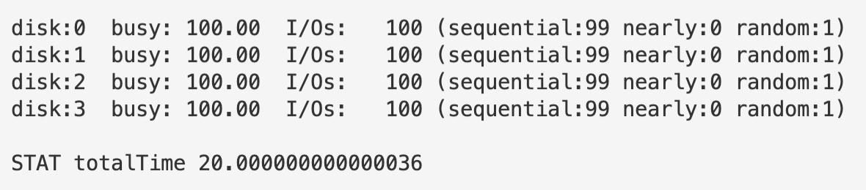

python3 raid.py -L 5 -n 100 -w 100 -W seq -t -c -S 16k

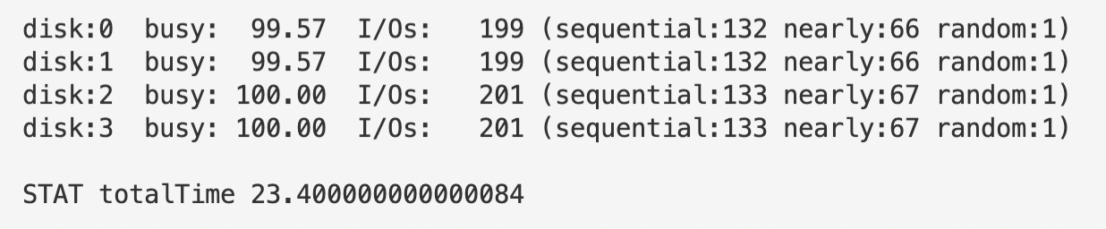

To make IO as efficient as possible, request size should be either 8k or 12k for RAID-4 and RAID-5.